Chapter 7, Solution 62.

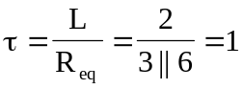

For 0 < t < 1, 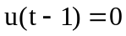 so that
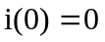, 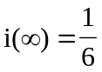
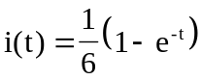

For t > 1, 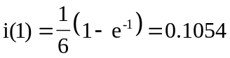
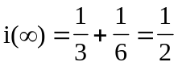
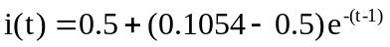
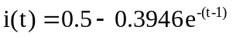

Thus,
